***Experiment No. 3***

Q- write a shell scipt to reverse the digit of a five digit integer.

***Code***

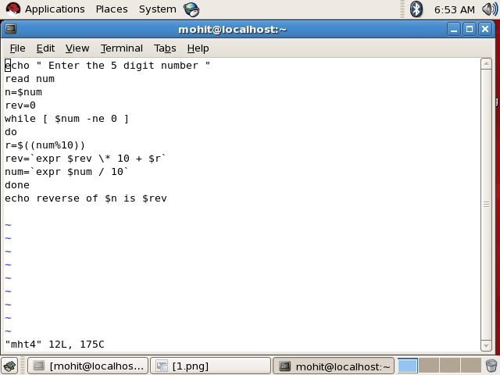

***Output -***

